Buffer Overflow Vulnerability Lab

CS5460 Assignment 5 Due: October 25 2017

Austin Derbique A01967241

2.2 Shellcode
For this part, I compiled the file call_shellcode.c that was given and successfully pulled up the shell. Everything was straight forward. File contents canbe found in the directory “2.2 Shellcode.”
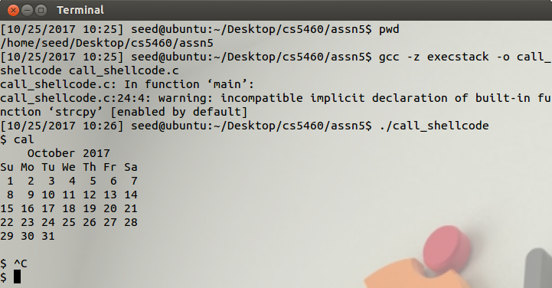
As you can see, I called the “cal” function to display the calendar inside the shell. After that, I pressed control-c which brought me back to the main shell.

2.3 The Vulnerable Program
I successfully managed to retrieve the message with the default file given. Files can be found in the directory “2.3 The Vulnerable Program.” Contained is the default stack.c program and the modified_stack.c program which has a modified buffer size. I found that a buffer of 12 seemed to work. The rest segmentation faulted.
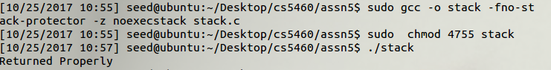
Note In the screen shot above, ./stack is actually executing the file now called modified_stack

2.4 Task 1: Exploiting the Vulnerability
This part was difficult. For the longest time, I was able to get the exploit.c file to compile and run, but I was getting segmentation faults from generating a bad badfile. Eventually, with the help of various online resources: https://github.com/wadejason/Buffer-Overflow-Vulnerability-Lab I managed to find some direction in how to guide my implementation. I eventually got a working result:
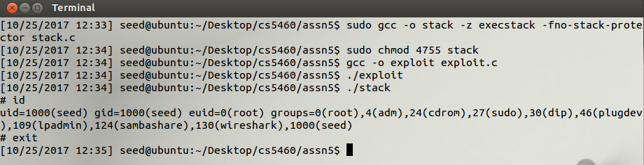
Code snippet from exploit.c:
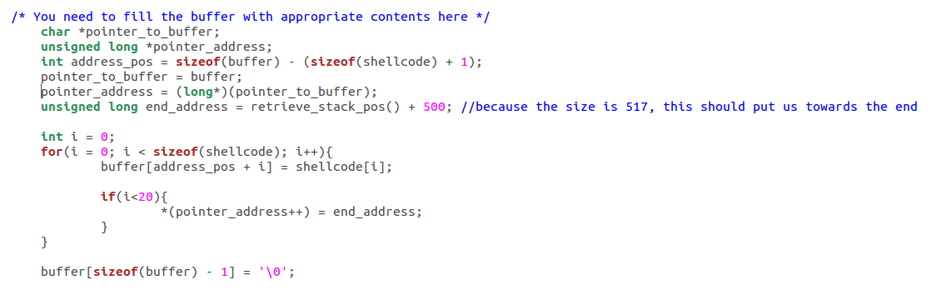
stack.c, stack, exploit.c, exploit, badfile, and the screenshot can be foun in the directory “2.4 Exploiting the Vulnerability.”

2.5 Task 2: Address Randomization
After calling the command to turn on randomization, I tried the call_shellcode program and successfully pulled up a shell. When I tried this with the stack, I received a segmentation fault.
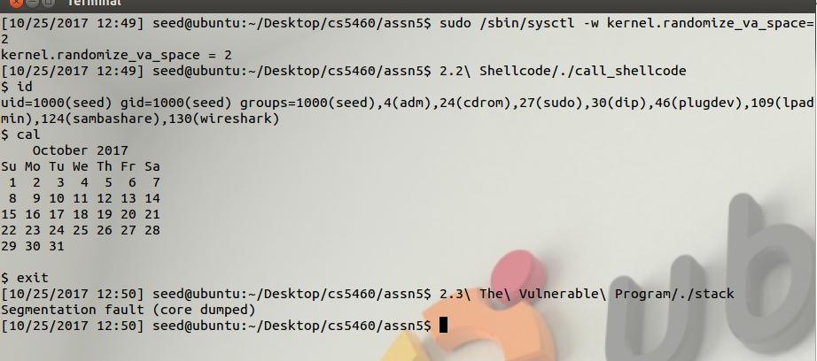
My observation is that by turning on randomization, it is a lot more difficult to attain the correct stack pointer because the safeguards in place change where the data is being written to in memory.. Specifically to prevent people from carrying out the attack we are trying to achieve.
The files for this can be found in the directory “2.5 Address Randomization.”

2.6 Task 3: Stack Guard
Doing as per the instructions, I first turned off randomization, then recompiled the vulnerable program without the -fno-stack-protector flag. This is documentation of what I did:
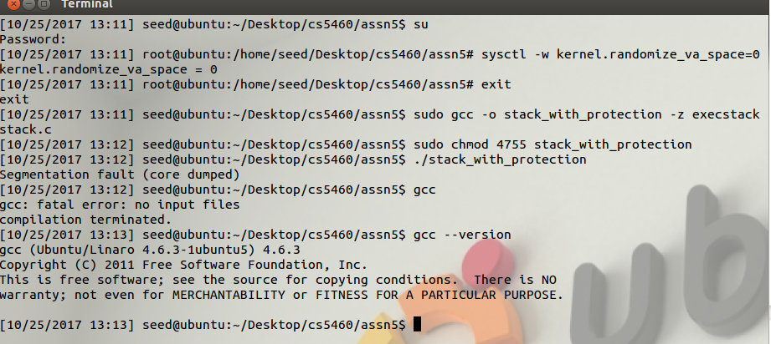
As you can see, my GCC version is 4.6.3, newer than 4.3.3, as mentioned in the assignment description. This means that Stack Guard is enabled by default and that I would need to disable it for my vulnerability program to work properly.
These files are available in the directory “2.6 Stack Guard.”

2.7 Task 4: Non-executable Stack
In this case, I took the normal stack.c program and compiled using the noexecstack flag. As a result, the program segmentation faulted and I was unable to get a shell. It does appear, though, that a buffer overflow was happening which appears to line up with what the assignment description is talking about.
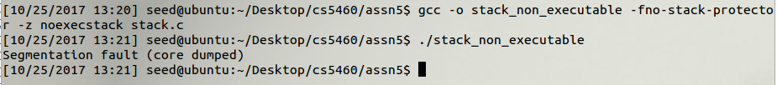
The files for this part can be found in the director “2.7 Non-executable Stack.”

